EXPERIMENT 4
4.Create a simple cloud software application for Library book reservation system for SIMATS library using any Cloud Service Provider to demonstrate SaaS include the necessary fields such as Title of the book, author, publications, Year, edition, no of copies, Rack no, status (taken/returned) etc.
Aim
To create a Library Book Reservation System for SIMATS Library using Zoho One as a cloud-based Software as a Service (SaaS) application.
Procedure
- Log in to the Zoho One cloud platform.
- Open Zoho Creator from the Zoho One applications.
- Create a new application for the Library Book Reservation System.
- Create a new form named Library Book Reservation.
- Add the required fields:
  - Student Name
  - Register Number
  - Title of the Book
  - Author
  - Publication
  - Year of Publication
  - Edition
  - Number of Copies
  - Rack Number
  - Book Status (Taken / Returned)
- Configure the field types according to the data required.
- Design and arrange the form for easy user interaction.
- Save and publish the form.
- Enter sample library book details into the form.
- Submit the form and verify that the entered data is stored in the cloud.
- Test the application by entering different book details and updating the book status to Taken or Returned.

- Verify that the Library Book Reservation System works successfully as a SaaS application.
INPUT
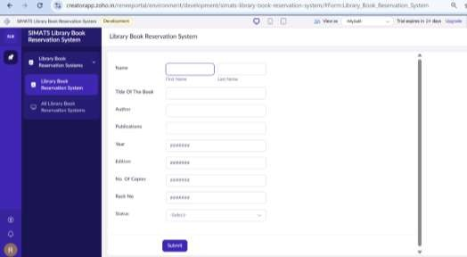

Output
